Project Design Phase-II
Technology Stack (Architecture & Stack)
Date | 12-2-2026
Team ID | LTVIP2026TMIDS82938
Project Name | ShopEZ : One-Stop Shop For Online Purchases
Maximum Marks | 4
Data Flow Diagram
The ShopEZ application is designed to accommodate three primary user roles: Customer , and Admin . Each role has specific responsibilities and permissions, managed through dedicated user flows and API endpoints. Below is an overview of the application flow for each role.
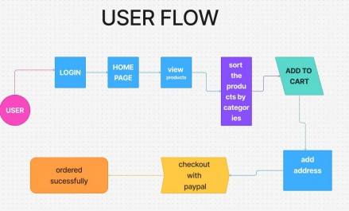
_{1.} Admin Flow
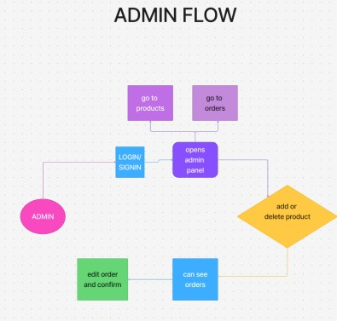
User Stories
 |  | User Type | Function  al  Require me nt  (Epic) | User  Story Num  b er | User  Story /  Task | Accepta nc e Criteria | Priori  t y | Releas e
 |  | Customer  (Mobile/  We b) | Registration | USN-  1 | As a user, I can register with email,  password,  and  confirm password | I can access my account  /  dashboar  d | High | Sprint  1

 |  |  |  | USN-  2 | As a user, I  will receive  a  confirmati on email once I register | I can click the confirmati on link and verify my account | High | Sprint  1
 |  |  |  | USN-  3 | As a user, I can register  using LinkedIn | I can access my  dashboa rd using LinkedIn login | Low | Sprint  2
 |  |  |  | USN-  4 | As a user, I can register using Gmail | I can access my  dashboa rd using  Gmail login | Mediu m | Sprint  1
 |  |  | Login | USN-  5 | As a user, I can log in with email and password | I can log in and access my  dashboar  d | High | Sprint  1
 |  |  | Dashboar  d | USN-  6 | As a user, I can view  products  and offers on my dashboard | I can  browse  listings  and add items to my cart | High | Sprint  1
 |  |  | Product  Search &  Filtering | USN-  7 | As a user, I can search for  products by name, brand, or | I can see filtered  results based on  search  keywords | High | Sprint  1

 |  |  |  |  | category
 |  |  | Cart &  Checkout | USN-  8 | As a user, I can  add/remo ve items to my cart,  modify quantity, and checkout | I can  update items and  proceed  to  payment | High | Sprint  1
 |  |  | Order  Tracking | USN-  9 | As a user, I can track my order status in real-time | I can see statuses like  Processi ng,  Dispatch  ed ,  Delivered | High | Sprint  2
 |  | Customer  Care  Executive | Customer  Support | USN  10 | As a support agent, I can  respond to  customer complaints and queries | Custome rs  receive  respons  es within 24 hours | Mediu m | Sprint  2
 |  | Administ rat or | Inventory Manage me nt | USN  11 | As an admin, I  can add/edit/d ele te product details and inventory | Products update instantly  across customer dashbo  ard s | High | Sprint  1

 |  |  | User  Manage me nt | USN  12 | As an  admin, I can manage  user accounts and handle complaints | I can  suspend,  activate, or  delete user accounts | High | Sprint  2

